Ground Control Points for aerial surveying
Objective

This guide will tell you what ground control points (GCPs) are, when and how to use them. Following this basic introduction will be a general outline of the steps to establish effective ground control for aerial mapping. Finally, there will be a step-by-step example of how we use ground control in our work.

Introduction to GCPs
Ground control points (GCPs) are used to give positional information to images and other aerial surveys such as lidar that are gathered with no image geolocation or to improve spatial accuracy of surveys that do. GCPs are points of known coordinates in the area of interest. Their coordinates have been measured with traditional surveying methods or have been obtained from other sources such as previous aerial images (google earth etc.). The known points must be identifiable in the gathered imagery/dataset. They are then used to scale and position (register) your gathered image so that it lines up with other geospatial data (maps, terrain models or anything else with geographical coordinates). Datasets that are collected without GCPs can be extremely difficult to align with pre-existing data, and therefore this can affect the accuracy or practicality of using this data for measurements. A good example of this would be using a UAV photogrammetric point cloud without GCPs in combination with a lidar digital terrain model to create a canopy height model.

Typical ground control points placed in an area prior to survey look like a small section of a checkerboard. This pattern uses high contrast colour and geometric shapes to enable precise location of where the ‘point’ of ground control is, i.e. the centre of the board (Figure 1).
Figure 1. Typical design for a GCP.

Ground control points are best made out of a waterproof material, especially if being reused. The surface (for photogrammetry) needs to be matt so that they do not reflect the sunlight, otherwise the glare makes them appear as white blurs in the imagery. In terms of size, GCPs for UAV operations are generally between 25 cm² and 1 m². this is all dependent on the resolution of the imagery and to ensure that there are enough pixels of each colour within the imagery – for example, 25cm² would be acceptable for 1cm imagery, as there would be 12.5 square pixels in each of the four quadrats, however, for 10cm resolution imagery, you would not be able to accurately locate the centre. They also want to be big enough that you can easily identify them in the imagery. Pre-made GCPs can also be readily purchased online in set and are often made of foldable material with pegs to make them more practical for field work.

Establishing an effective GCP layout

Decide how many GCPs you need and where to place them. Each GCP should appear in multiple images/scans taken from different positions. At least 5 GCPs are recommended by most sources, spread across your area of interest. GCPs should be evenly spaced and shouldn’t be right on the boundary of your surveyed area so that they appear in multiple images. Best practice also dictates placing a GCP within the centre of an area of interest to avoid systematic errors such as the “bowl effect” that is caused by the build-up of minor errors in the measurement of the camera lens model within the photogrammetric process. GCP Layout for a basic flight plan might follow a simple “table legs and centre piece” layout:

Figure 2. Standard GCP layout for a simple aerial survey of a small area.

A larger stand, particularly one that comprises a more complex shape, will require additional GCPs to reduce any errors that may occur in the reconstruction of any protrusions of land from the general area. This is especially true in sites that have more complex topography:

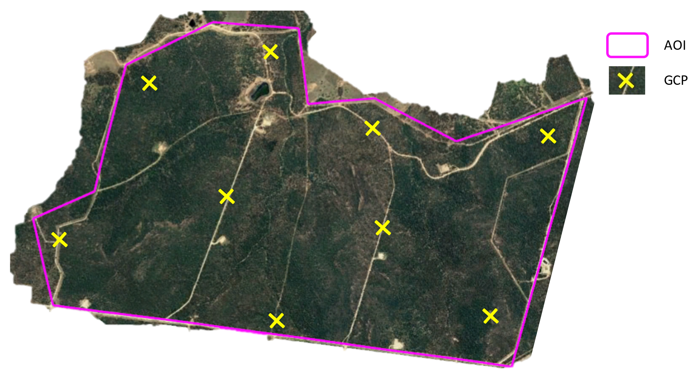
Figure 3. Typical layout of GCPs across a larger, more complex AOI

The basic steps for ground control survey and application are as follows:

- Take a rough map of where to place the GCPs into the field with you. This may be a google earth image you have used to plan placement close to tracks, or a PDF on a mobile app like Avenza (https://www.avenzamaps.com/).

- Place GCPs in the field as close as practical to the plan to maintain even spacing. Get an accurate position of the centre of the GCP with a GNSS unit that conforms to the mission accuracy. GCPs should have a clear view of the sky and be placed away from tall obstructions so that they are visible from multiple angles above.

- Carry out data capture (UAV imagery etc).

- Process the images in photogrammetric software to create an orthomosaic using the location of the GCPs in the image and adding in the known coordinate data of the GCPs, as per the individual instructions for the software. As an example, instructions for Pix4D can be found here: https://support.pix4d.com/hc/en-us/articles/115005242946-How-to-use-GCPs-for-processing-on-PIX4Dcloud.

Detailed workflow of ground control for aerial imagery

To demonstrate a procedure for the establishment of ground control, the following procedure has been adapted from Scion’s Autonomous System’s SOP. There is a wide variety of software for photogrammetry, and they all have their own guidelines and, in some cases, additional applications to aid in carrying out field surveys. In this guide, we attempt to use easily accessible, open-source software and point to alternative packages that can perform the same tasks, where they can be identified.

Step 1.
Look at the terrain and plan out GCP placement as outlined above. You can do this in Google Earth or directly in GIS software if you have previous georeferenced images. QGIS software is free or other GIS software’s such as ESRI products have good capability. Both QGIS and ESRI have field maps versions where a digital map with planned GCP points can be taken on a device with GNSS capability into the field (this includes maps produced on Google Earth). Avenza is another well-known mobile application for taking georeferenced PDF maps to the field for navigation. Avenza is free for storage of up to 3 maps on a mobile device before a subscription must be paid. The device could be a cell phone or tablet and allows you to see your location relative to your planned GCP point live on the screen.

Step 2.
Peg the GCP flat to the ground in an easily visible location and take GNSS observations of its centre. The accuracy of your GNSS position will determine the accuracy of the final geolocation of your imagery. We use a GNSS receiver that is corrected by Real time Kinematics (RTK). RTK makes corrections for ambiguity in satellite position by using a fixed ground beacon as well as satellites. A GNSS receiver that is RTK capable can fix onto a LINZ (Land Information NZ) RTK transmitter by logging into NTRIP protocol (Networked Transport of RTCM via Internet Protocol) account that enables the mobile RTK GPS receiver (rover) to access data from the RTK base station over the internet to achieve 1cm accuracy if cell phone reception is available. PositioNZ (https://www.linz.govt.nz/products-services/geodetic/positionz), is LINZ’s free NTRIP, which you can sign up for. You can also sign up for a more accurate paid version. This process increases accuracy from meters to centimetres. It is helpful if your accurate GNSS is tethered to your field maps capable device so that the gathered waypoints can be named and added to a map of actual GCP locations. In this particular workflow, ESRI Field Maps app (https://www.esri.com/en-us/arcgis/products/arcgis-field-maps/overview) was used with two maps: first, the planning map on which GCPs are marked off as they are placed and, second, another map on which actual locations of the GCP placement are recorded with high accuracy. This, of course, could be done by marking off the GCPs that have been placed on a paper plan and saving the waypoints directly into a GNSS for upload to a GIS platform upon return to the office. By tethering your phone by Bluetooth to your GNSS you remove the need for this extra step upon return to the office. The Arrow Gold GNSS receiver (EOS Positioning Systems Inc., Terrebonne, QC, Canada) is an excellent and affordable GNSS unit with this capability and a good level of accuracy.

For more information on GNSS accuracy, Interpine have put together an excellent appraisal:
https://interpine.nz/gps-accuracy-estimate-epe-what-is-it/.
Anatum GeoMobile Solutions have also put together some good reports on Bluetooth enabled GNSS receivers that can be paired with mobile devices, their benefits, and comparisons between brands. Worth a read:
https://www.agsgis.com/Everything-You-Need-to-Know-About-GPS-for-Switching-to-Mobile-GIS_b_37.html
https://www.agsgis.com/Bluetooth-GPSGNSS-For-Mobile-GIS-Field-Tested-and-Compared_b_38.html.
They also have a good explanation of what RTK GPS is:
https://www.agsgis.com/RTK-GPS-Explained_b_6.html

Step 3.
A common option for orthomosaicing and georeferencing the aerial imagery, once it has been collected, is the Pix4DMapper photogrammetry software. There are numerous additional photogrammetric software available, and an appraisal of some of these software can be found on the Tools For Foresters website (https://www.toolsforforesters.co.nz/tools). A basic overview of this is that you input all of your aerial imagery, then the software builds a sparse point cloud by identifying matching points between the imagery. The coordinates of your GCPs are then uploaded and manually assigned to their associated images, tying the model to the ground survey data, prior to the final stages of dense point cloud and orthomosaic creation. The specifics of this process in PIX4D can be viewed on the PIX4D website:

Image import and processing steps
https://support.pix4d.com/hc/en-us/articles/360000831423-Image-import-and-processing-steps-PIX4Dfields

GCP / MTP Manager
https://support.pix4d.com/hc/en-us/articles/202558359-Menu-Project-GCP-MTP-Manager-GCP-MTP-Table

There is also a getting started manual which tells you about the software and contains some good guidelines for gathering aerial imagery regardless of what image processing software you use; https://support.pix4d.com/hc/en-us/articles/204272989-Offline-Getting-Started-and-Manual-pdf

Slight differences for a LIDAR workflow

GCPs can also be used for assessing the accuracy of UAV lidar point clouds, or coregistering these datasets with other data set. GCPs can be created in the same high-contrast “checkerboard” format as for photogrammetry, however, for lidar surveys, they must be made of a retroreflective material that is easily identifiable in the dataset. A good example of a workflow for the use of lidar targets (the CloudReg method) can be found in the following paper by Scion: https://doi.org/10.3390/rs14143344

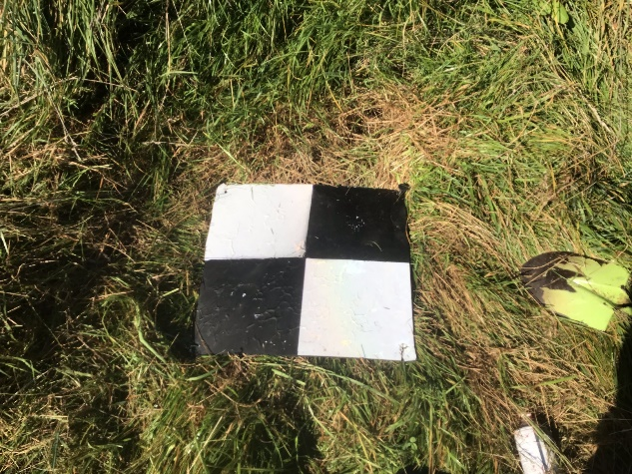
Figure 4. Retroreflective lidar target in use in the field.

Point cloud processing software is used at Step 3 of the ground control workflow discussed above instead of photogrammetry software. CloudCompare is an excellent and highly functional tool for this purpose, which is completely free and open source. Here is a link to a video on how to align a point cloud with GCPs using cloud compare. https://www.youtube.com/watch?v=kXqY6W5CjT0

