UAV Operational Plan for -insert project name-
Planned Date for Flights: / /20 Location:
Access Confirmed? Yes / No Access Requirements - Key: Yes / No Permit: Yes / No
Access Comments:
NOTAM Required? Yes / No NOTAM No.
Crafts Required:

Objective <insert a brief description of the objective – useful for toolbox and review>
The purpose of this data collection is to...

Field Intentions <insert all information pertaining to the project, contact details and detail an emergency procedure (if required – some companies may already have this well documented)>

Link to Project Folder: -copy and paste link here-
Vehicle used: -insert vehicle rego-
Pilot name: Observer name: Additional Staff:
Communications: <circle what you have available – always ensure you have backups>
Cell phone / Sat Phone / Radio Telephone / Aviation Radio / VHFs / Other:_____________
Pilot Contact Details: mobile: ICE: name: Number:
Observer Contact Details: mobile: ICE: name: Number:

Additional contact details. <these may not be useful for all companies, so please customise>
Client Contact Details: Name: Contact Number:
Landowner Information: Name: Contact Number:
Forest Security Information: Name: Contact Number:
Estimated Time for Departure: Estimated Time due back:
Contact Procedure:
- At Office, planning phase:
  - Fill out page 1 of this form.
  - Decide on Nominated Contacts to notify of your operations (2 is good to have a fall back)
    - These people should be present at your office at the time of the operation, and not on leave etc. Suggested people are your TL/Manager/project leader etc.
  - Email the Nominated Contacts to ask them if they are willing/able to carry out this role, and assign one of them as the Prime Nominated Contact for the operations.
    - The Prime Nominated Contact will be the person who is responsible for calling the field crew if they are not heard from by the check in hour. It is also their responsibility to activate the response for if the field crew are unreachable or do not check in.
  - CC your Nominated Contacts into any correspondence related to carrying out the field operations so that they are up to speed on the plans.
  - Consider setting up a calendar invite for your Prime Nominated Contact, so that they are aware of what time they need to attempt to make contact, if the field crew has failed to do this. This process is only activated when they respond to this.
- On day of operation,
  - Check phone battery on morning of operations.
  - A text will be sent to your Nominated Contacts, informing them of your departure.
  - If possible, send a text to your Nominated Contacts when you arrive at and leave the field
  - A text will then be sent to your Nominated Contacts informing them of your arrival back at the office.

Tasks <insert a list of operations to carry out at the site>
<delete as necessary> For multiple sites these tasks are all to be repeated across each site:

- -List tasks here- <e.g. collect RGB/multispectral imagery/LiDAR/establish GCPs etc>
- -List tasks here-
- -List tasks here-
- -List tasks here-

Pre-operational Checks for the Office:
- Check weather for flight date and time
- Complete this flight planning document, including checking NOTAMs/AIP/Supps/VNCs
- Seek written landowner permission (email is fine)
- Check the airspace you want to fly in to ensure it is safe and permitted
  - Consult VNCs
  - Log Flight with Airshare
  - Apply for ATC (if required)
  - Aviation Radio channels identified
  - Apply for NOTAM if required
<this only applies to Part 102 certified organisations – if a flight requires a NOTAM (e.g. for flights >400ft) and you do not have Part 102, then an appropriate contractor should be engaged for the work>
- Is access sorted for mission (gate keys/radio channels/permits)
- Vehicle booked/prepared/checked?
- Flight plans created and saved?
- Firmware release version current and up to date on craft?
- Aircraft maintenance up to date?
- iPad/Tablet fully charged
- Batteries fully charged
- RC Batteries fully charged
- SD Cards emptied and packed?
- Consult Hazard Register to refresh hazards (if required)
- Risk assessment conducted (See AOI and Hazard Assessment section)?
- App subscriptions up to date and signed in (if required)
- Sign-in to app licenses (Arc/Pix4D/Map Pilot etc) before leaving Wifi zone.
- Check Mobile phone coverage in area through service providers web site

Site map: <take a screenshot of Google Earth/your GIS with AOI highlighted with a shapefile etc. this helps give some context, and is a good reference for in the field>

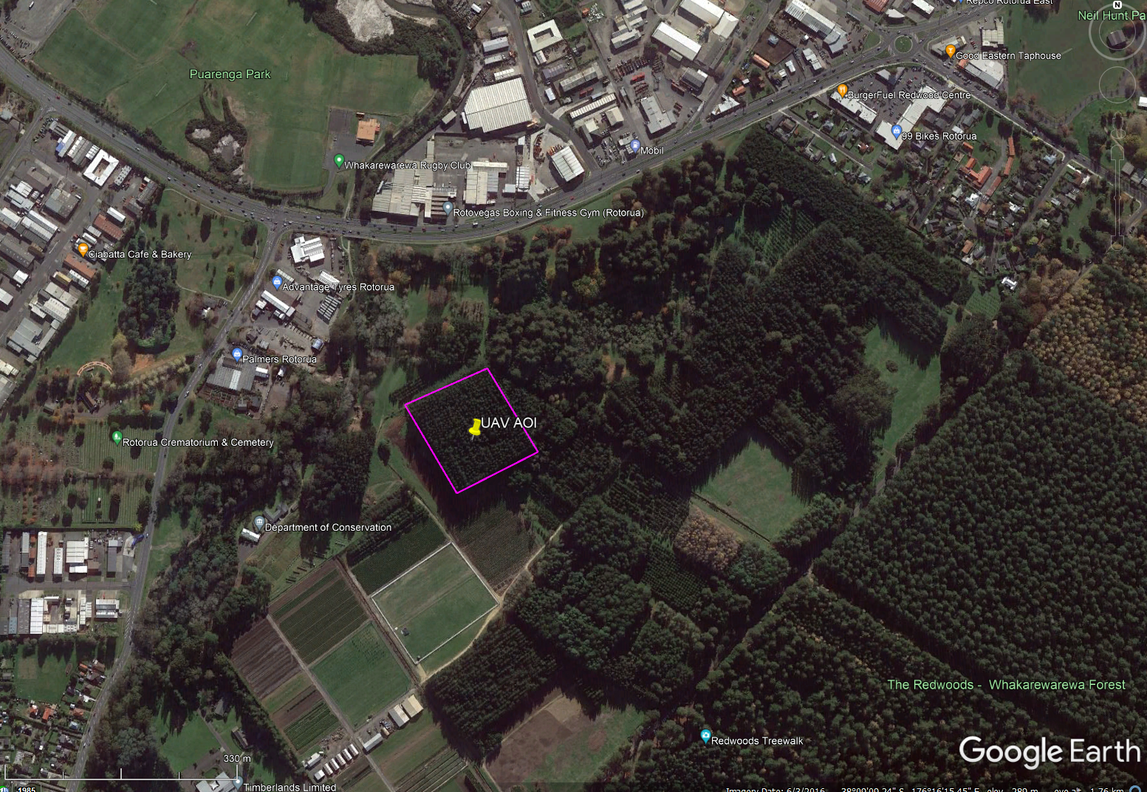

Kit List <add/delete items as necessary: this list is very useful for ensuring you don’t forget items you need in the field>

Item | Yes | No | Comments
UAV <insert craft name/model>
X sets Batteries <insert no.>
RC(s)
Car Charger for UAV batteries
Chargers for batteries
SD Cards x 2 <minimum>
iPad/Tablet
Sun shade for iPad/Tablet
Lightning + Android Cables
UAV Field Laptop x 2
UHF Radios <if using an observer>
VHF Aircraft Radio (if applicable)
Satellite Phone <useful if in remote areas where you need comms>
LiPO Bags <useful in case of hard landing/fault>
1st Aid Kit
GCP markers & pegs
Take-off Mat
Anemometer
Fire Blankets
Fire Extinguisher
Chairs (if applicable)
Field table (if applicable)
Sunscreen
Spray Paint
Additional sensors (if applicable)
RTK base station (if applicable)
RTK base batteries (if applicable)
Generator (if applicable)
Extension leads & Multi-boxes
MOBILE PHONE CHARGED?

AOI and Hazard Assessment:

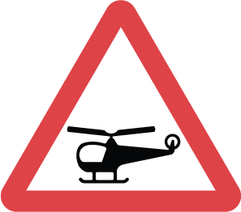
H2
H1
Hazards: Aircraft Hazards
Take-off Locations: Primary – H1
Secondary – H2

<copy and paste hazard logo’s and place them over the map to indicate hazards (useful for toolbox)>
<pre-determine a take off location from your GIS, and identify a secondary in case that one is not good when you get to the field. This can save a lot of time driving around>

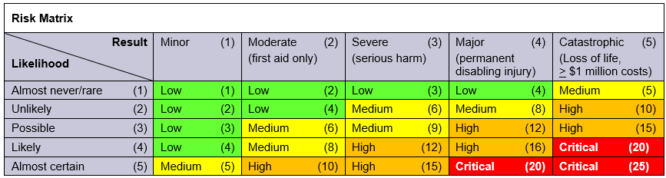
Hazard Assessment <Use the risk matrix above to fill out the potential hazards, severity, likelihood, rating and appropriate controls for your operations in the table below. A few examples are filled out>
Hazards | Severity of Risk | Likelihood | Rating (/25) | Hazard Control | Control Comments
Common UAV operational hazards are listed below. Please write in any additional site specific hazards | Refer To Risk Matrix on p4. | Refer To Risk Matrix on p4. | Refer To Risk Matrix on p4. | 1.Eliminate 2.Substitute, Isolate or Engineering Controls 3.Administrative Controls 4.PPE | Write in any site specific comments to be aware of that will help to control hazards.
Operation Close to Highway – crash into road, distract drivers, could cause accident | 2 | 5 | 10 | 1 | Ensure flight plans are constrained to areas off the main highway. If it is unavoidable, then consult NZTA.
Public access to this area – pilot distraction, could cause an incident | 3 | 1 | 3 | 4 | Put up signage, take an observer, wear high viz, tape off areas if appropriate
Dogs in the vicinity – could distract pilot, dog could attack craft causing damage or injury | 3 | 1 | 3 | 2, 4 | Put up signage, take an observer, wear high viz, tape off areas if appropriate, wear appropriate PPE
Poor Visibility/RC connectivity due to trees – could lose control of aircraft, which could cause an incident in controlled airspace | 2 | 5 | 10 | 1 | Ensure VLOS at all times. Employ methods such as use of a MEWP if this is not possible. Set craft to RTH at appropriate altitude if signal is lost.
Low Flying aircraft as in the control zone for NZRO – mid-air collision if the craft is not | 2 | 5 | 10 | 3 | Ensure that an Airshare has been put in and flights are coordinated with NZRO ATC. Be vigilant, maintain VLOS at all times and use an observer to monitor airspace. Also consider monitoring an aircraft VHF to keep track of what is going on in the control zone.
Other:

Other:

Other:

Other:

Other:

Other:

Flight Plans <insert images of flight plans here – this can be really handy if you need to make changes in the field, or for future reference>

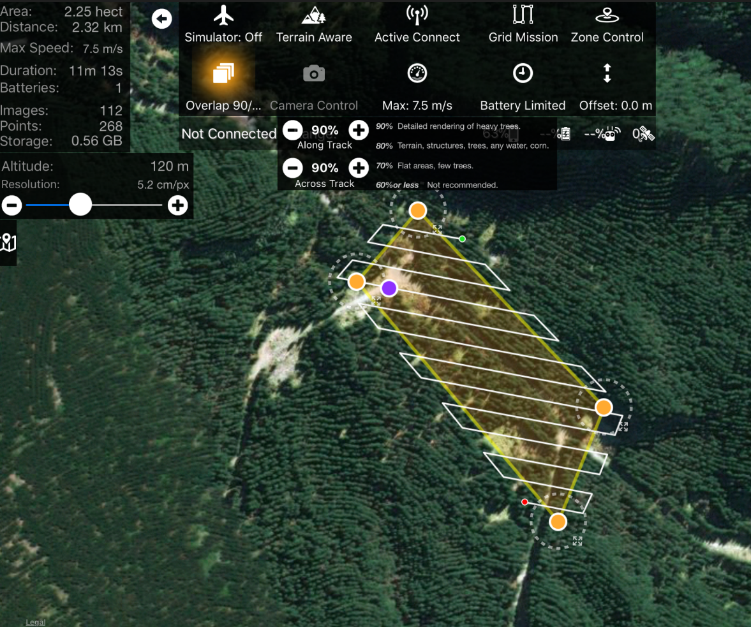
x
x
x
x
x
x
GCPS

<Consider adding the locations of GCPs prior to heading out to the field, so that you can be sure that their coverage is even and you already have an idea of where to go when you get to the field to set up the site – Copy and paste from above and move around>

Craft required
Phantom 4 Pro

<If doing multiple flights, add additional flight plan images and label them accordingly>

Airspace <take a screenshot of the local airspace from your VNCs>

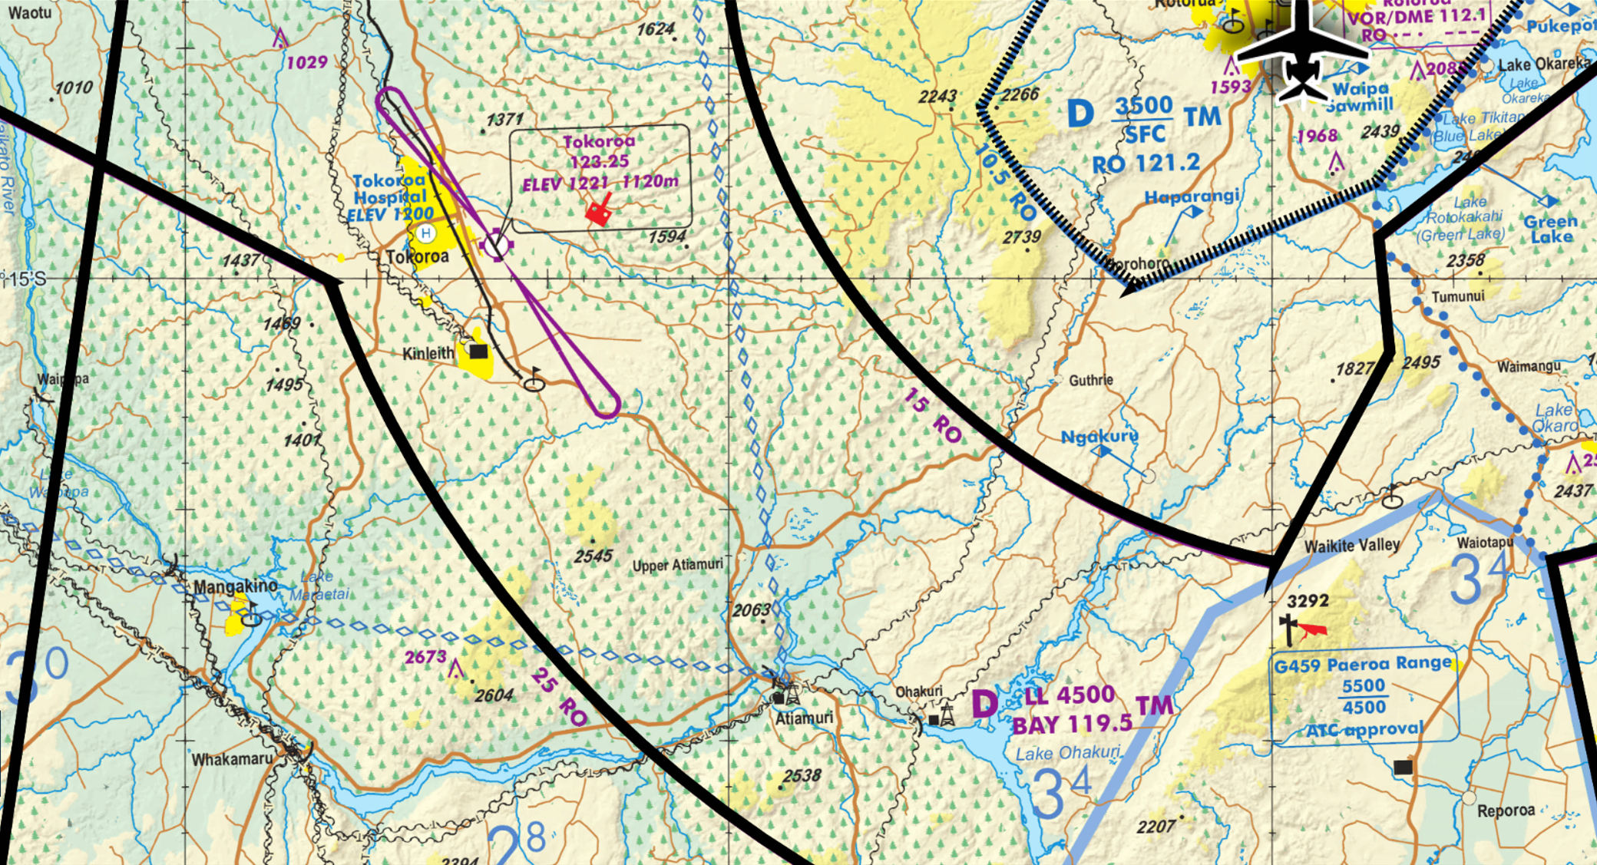
Area of Interest
<Consult VNC’s prior to heading to the field, this will give you a good understanding of the airspace and what requirements there may be for conducting flights in this area. At the very least consult Airshare>
<Remember that as a UAV operator you are also in control of an aircraft and have a legal responsibility to ensure you understand the airspace that you are flying in, taking all possible precautions to ensure the safety of other airspace users – a helicopter will not be able to see and avoid a small UAV and if they hit your craft, it will be a serious incident>

- Checked NOTAMs/AIP/Supps/VNCs

Airspace information:
- <identify the nearest aerodrome/airport, any special airspace (CFZ, MBZ etc), the local call sign (it can be useful to ask a local operator if unsure, or just state something obvious (i.e. Morrinsville Traffic, if operating in the Morrinsville CFZ, or Kaingaroa traffic if near Kaingaroa Forest), plus the aircraft VHF frequency so that you can tune in and observe broadcasts>
- AOI is 5nm S NZTO (uncontrolled Aerodrome) and 5.5 S of Tokoroa Hospital.
- Falls below the Morrinsville CFZ (LL CA = 4500’)
- Area call sign – Kinleith traffic
- Radio Frequency – 119.1 (unattended)

Airspace Comments:
<add any comments here that may be of use for this flight or future flights in this area, e.g. –“Tram Road is a busy thoroughfare for air traffic heading south from Tokoroa, especially Ag pilots, who fly low and follow the Tram Road as a navigation reference”>

Contacts <google all local agricultural, commercial and tourism operators, plus local aviation clubs and contact them>

<In areas of busy aviation, it can be useful to call up relevant operators when flights are booked in, to inform the pilots of your operations – you’ll be surprised how grateful they are.
<Alternately consider putting together an email with a map of your planned flight area, altitude, time and date of operations plus what you intend to do (I.e. UAV mapping) and send it to all relevant operators a day or more before your intended ops>
<Inform them of your flight location (Kinleith forest, Xnm S NZTO), and altitude (express proximity to Tram Road for that flight) – pilots will know immediately if you are in their vicinity>
<If calling pilot, do so as early as possible the day before (usually between 1500 and 1800 hours) – pilots fly early, get back early and go to bed early, so try to work with them>
<once you have done this once or twice, you tend to build up a good list and then its just copy and paste/eat sleep repeat…>

- Rotorua <insert Nearest big town name and search for details of operators, then add below>
    - Operator 1 company name, contact name, number, web address, contact number
    - Operator 2 company name, contact name, number, web address, contact number
    - Operator 3 company name, contact name, number, web address, contact number
- Tauranga/Te Puke <second biggest local town name and details of operators below>
- Waikato <regional operators and details of operators below>

